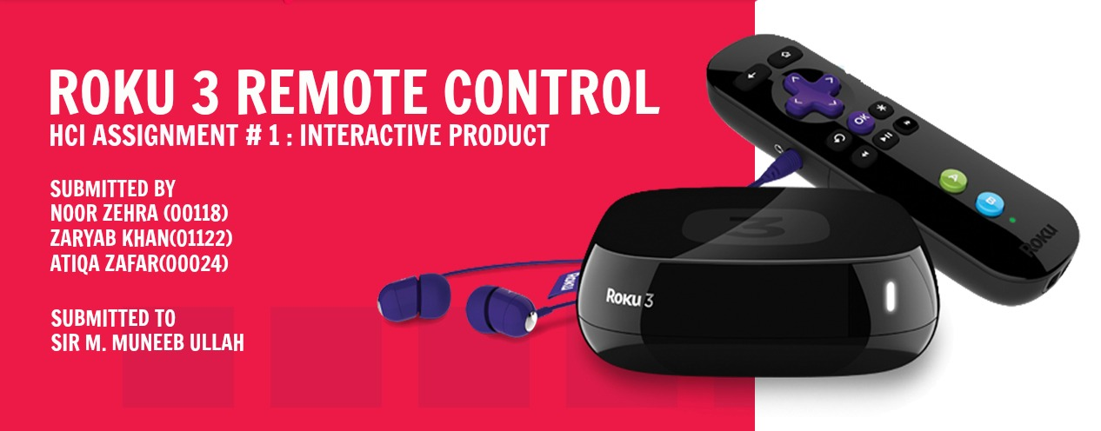

**Introduction**

The everyday handheld device we chose to study thoroughly and practice our concepts of usability, user experience goals and basic design principles was the remote control of ruko3 device.

Roku3 is a little box that makes it easy to enjoy the best movies, TV shows, music, games and more on your TV by streaming it directly from the Internet. Millions of people use Roku3 every day to access their favorite entertainment instantly and on demand. The ruko3 is a device similar to the PTCL smart TV device or the SUN TV device that is widely used throughout Pakistan. The only difference being that it needs an internet connection to be set up and it provides a more functionality than the former.

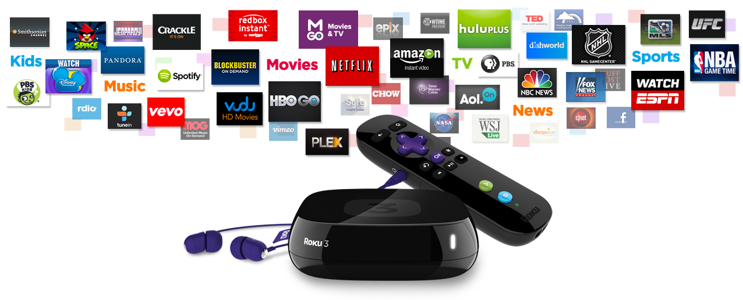The designers of the ruko3 remote control had studied the problems users had pointed out in remote control’s prior to the ruko3 remote control so they wanted to design a product that was easy to understand, effective to use and enjoyable from the user perspective. Studies have shown that users were not comfortable around remote controls that offered a large number of buttons as only a few buttons are frequently used in a TV device remote control. Furthermore a large number of inconvenient remote controls offer more than one way to access a certain option such changing the channel or adjusting the volume. The developers of the Ruko3 remote control took these problems into consideration and designed a remote control that appeared easy to operate for the users at first glance by reducing the number of unnecessary buttons and placing them on areas of the remote control which could easily operate.

**User Interaction**

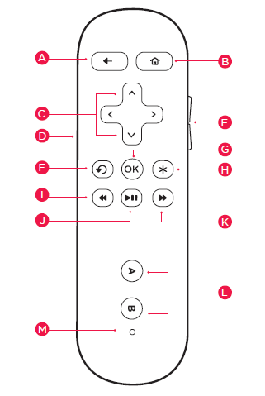The roku3 remote control looked like a pretty neat and clean remote on first sight. It only had a few buttons on it which actually makes it pretty convenient to use, given that in the present age people do not memorize the channel list and rather scroll up and down on the menu. There were a total of 16 buttons on the remote and the functionality of each button could be easily anticipated apart from a few buttons where its functionality seemed a bit ambiguous.   
  
The button ‘A’ with an arrow icon appeared to be a return button that would help return to a previous option in the main menu. The button ‘B’ with a home icon appeared to be a main menu button (that would direct the user to the main menu.) The four buttons labeled under ‘C’ appeared to be navigational buttons that would help the cursor go up, down, left or right in the main menu. The buttons labeled under ‘E’ on the side of the remote appeared to be volume adjusters. The button ‘F’ appeared to be a refresh button. The functionality of it couldn’t be anticipated (as to when it will be used). The button ‘G’ with an OK label appeared to be a selection button (that would help select an option in the menu). The button ‘H’ could not really be anticipated for a specific purpose. The best guess I could come up with was that it might be used to alter the TV Brightness. The buttons ‘I’ ‘J’ and ‘K’ were easy to guess. They were to be used for rewind, pause/play and forward options respectively. The buttons ‘A’ and ‘B’ had bright colors and as far as my knowledge of remotes guide me, these buttons should be used to perform certain special options in the menu e.g. transforming the channels list in the menu from ascending to descending.   
  
There was a port at the side of the remote labeled as ‘D’. It seemed as if it were a jack to plug in headphones so you could turn on the TV, plugin your headphones and watch a cricket match on full volume without disturbing the people around you.   
  
There was a small LED labeled as ‘M’ here that I anticipated to blink whenever we perform an action such as change the channel.  
  
There was also a strap attached at the bottom of the remote which indicated that the remote may slip from the users hand and to prevent it from falling down and breaking, the designers also attached a safety wrist band.

One thing which bothered me on first sight was that I could not find a mute button. The mute button is quite an important feature as it is sometimes necessary to turn off the volume in a single click. An example is when we turn on the TV and find out that it had been switched off in full volume. Muting the TV bring such a relief to our ear drums!

***\*the reviewer had no previous knowledge of the remote control’s buttons and was made to guess the functionality of every button. This helped us understand how easy is it and how long does it take to get started using Ruko 3 remote control to perform core tasks.***

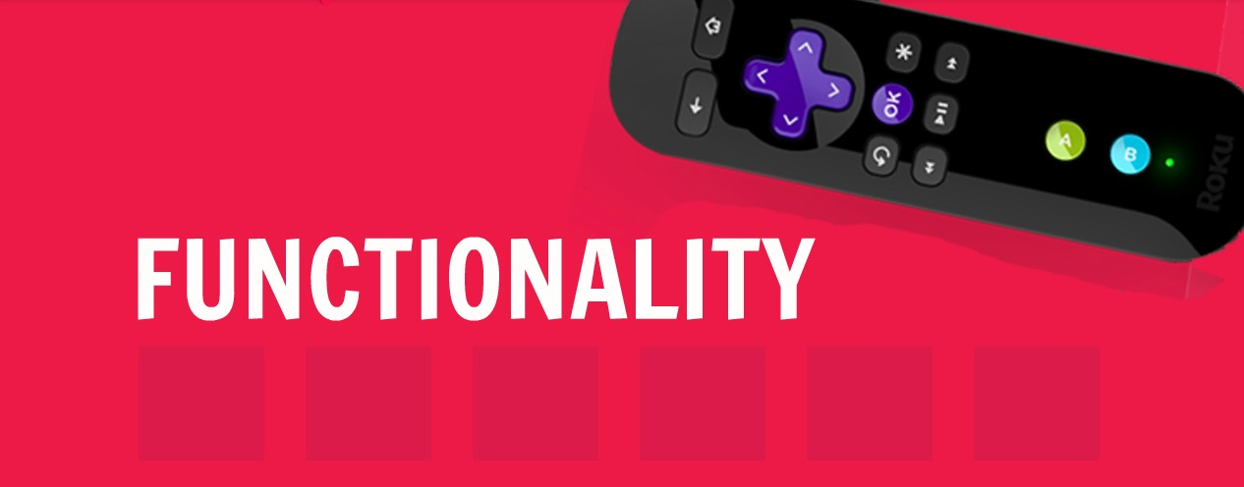

First let us discuss a little interesting facts about the Ruko3 enhanced remote:

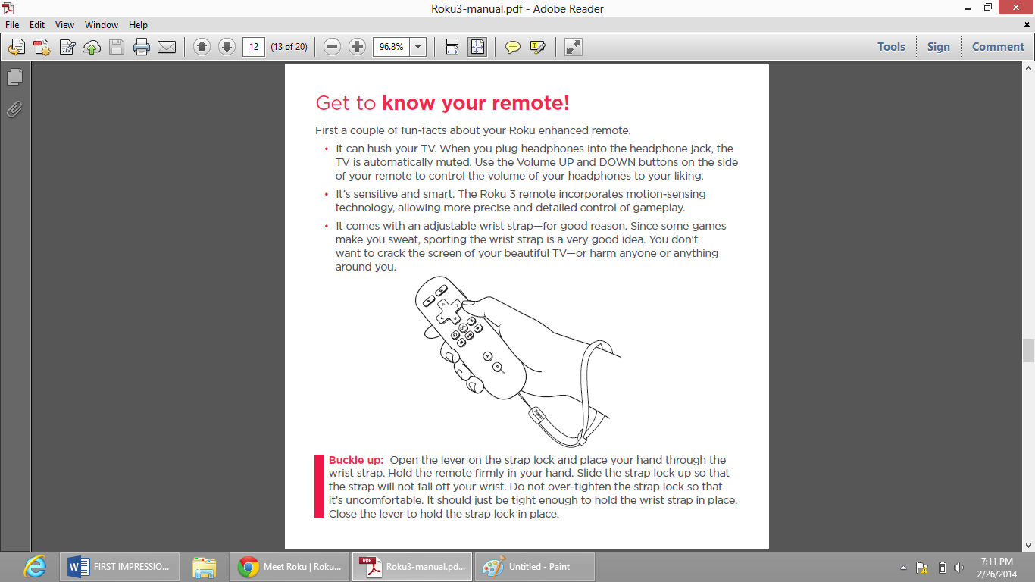**GAMES USING RUKO’S REMOTE**

The Roku3 device offers quite a few games to be played on the TV using the Ruko3 remote as the controller. The remote provides incorporates motion-sensing technology, allowing more precise and detailed control of gameplay.

**RUKO’S WRIST STRAP**

It comes with an adjustable wrist strap for good reason. Since some games make a person sweat, sporting the wrist strap is a very good idea as it is quite possible for the remote to slip off the hands and crack the TV screen or harm someone.

**PLUGGING IN THE HEADPHONES**

You can plug in a pair of headphones into the headphone jack and listen to whatever's playing on the TV. Plugging in the headphones also automatically mutes your TV, and headphone volume can be adjusted using the rocker on the right side of the remote. Another smart feature is that the headphone volume leaves the TV volume unaffected, so raising the volume of the headphones wont effect the TV volume when the headphones are plugged out.

**TECHNOLOGY USED**

The Ruko3 remote uses radio frequency instead of infrared, so a direct line of sight to the Roku3 player is not required to operate it.

**FUNCTIONS OF INDIVIDUAL COMPONENTS**

BUTTON A: [BACK] Return to previous screen

BUTTON B: [HOME] Return to Roku3 home screen

BUTTONS C: [UP] or [DOWN] Move up or down; [LEFT] or [RIGHT] Move left or right

JACK D: [IN-EAR HEADPHONES JACK] Plug in your in-ear headphones here

BUTTON E: [VOLUME +/-] Increase/Decrease the volume of your headphones

BUTTON F: [INSTANT REPLAY] Replay last 7 seconds of video

BUTTON G: [OK] Select an option from a menu

BUTTON H: [OPTIONS] View more options

BUTTON I: [REV SCAN] Rewind, scroll left one page at a time

BUTTON J: [PLAY/PAUSE] Start or pause playback

BUTTON K: [FWD SCAN] Fast forward, scroll right one page at a time

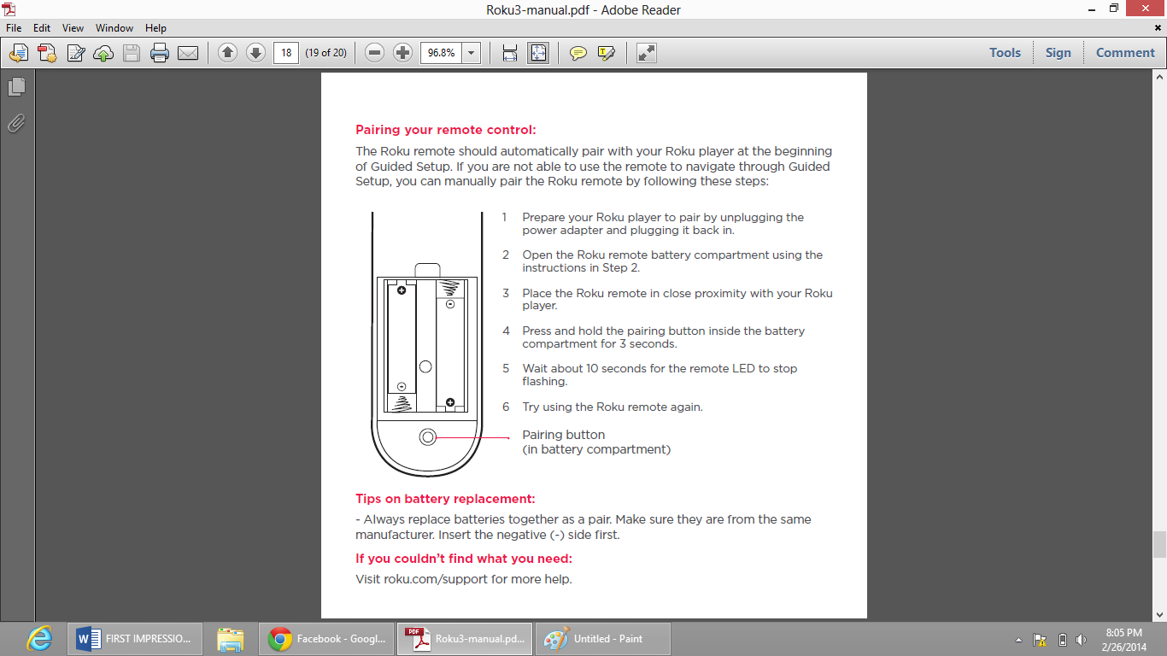BUTTONS L: [A & B] Action buttons for gaming

LED M: [STATUS LED] Displays remote usage information

**POWER SOURCE OF THE REMOTE CONTROL**

The Ruko3 remote control is run by 2 AA sized cells which are easily available locally in most markets.



1) The user expects the remote to operate even when the Ruko3 device is not in the line of site of the remote.

2) The user expects the remote control to be reliable, durable and tough.

3) The user expects the remote control to be water resistant.

4) The user expects the remote control to be run on locally available batteries.

5) The user expects the remote control to be light weight.

6) The user expects the remote control to have minimum buttons as possible bearing in mind that a few important functionalities such as adjusting the TV volume, changing the channel, muting the TV and turning off the Ruko3 player is provided by the buttons directly.



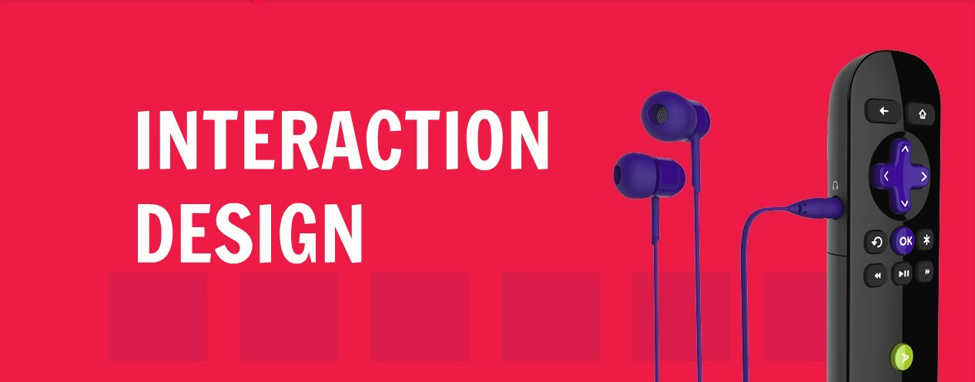

While reviewing the design of the Ruko 3 remote control, we questioned ourselves a number of questions, as follows, to evaluate how usable the device is as an interactive product. Is it easy to learn and effective to use, and does it provide an enjoyable user experience. These questions helped us understand the usability and user experience goals and the design principles considered in designing this product. By this, we mean that we understood how concerned the designers were in meeting specific usability criteria (efficiency of the product) and what the quality of the user experience is (aesthetically pleasing).

* **Usability Goals**

1. **Is Ruko 3 remote control easy to understand?**

Yes, Ruko 3 remote control is very easy to understand and use. We asked ourselves a simple question if a user can get started straight away and become competent at carrying out tasks without much ado and found out that it doesn’t take a long time learning how to use the remote control. In a small drill for writing the first impression section, we made one of our members have no previous knowledge of the remote control’s buttons and to guess the functionality of every button. This helped us understand how easy is it and how long does it take to get started using Ruko 3 remote control to perform core tasks.

In Ruko 3, the button layout is designed to be easy to operate for the users at first glance by reducing the number of unnecessary buttons and placing them on areas of the remote control which could easily operate. Moreover, the labelling icons are well defined and depict the functionality in a sound way.

1. **Is Ruko 3 remote control efficient to use?**

Yes, Ruko 3 remote control is very effective and efficient. By effectiveness, we mean how good it is at doing what it is supposed to do, whereas efficiency refers to the way it supports the user in carrying out their tasks.

Usually, users are not comfortable around remote controls that offer a large number of buttons. Few buttons are hardly used to perform any action in a TV device remote control. And secondly, a large number of inconvenient remote controls offer more than one way to access a certain option such changing the channel or adjusting the volume.

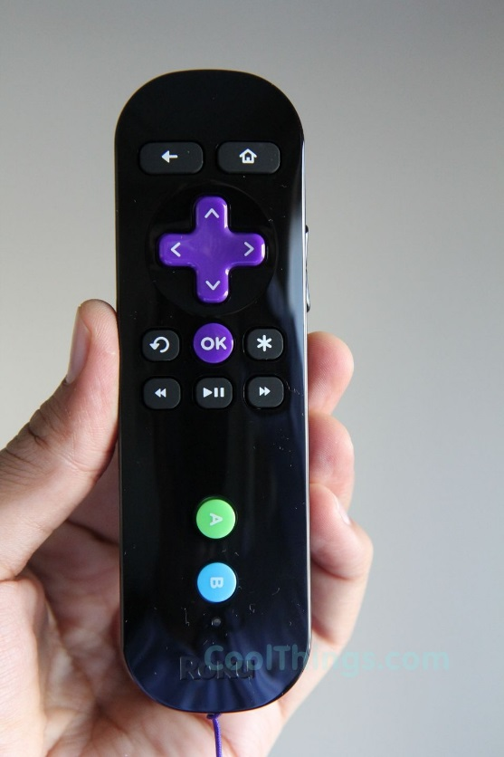The designers of the Ruko3 remote control took these problems into consideration and designed a remote control that appeared easy to operate for the users at first glance by reducing the number of unnecessary buttons and placing them on areas of the remote control which could easily operate. There are a total of 16 buttons on the remote and the labelling icons are well defined and depict the functionality in a sound way, apart from a few buttons where its functionality seemed a bit ambiguous. Such a reduced number of buttons makes it pretty convenient to use and learn, given that in the present age people do not memorize the channel list and rather scroll up and down on the menu. By learnability, we mean that the user does not even have to look at the remote and make it function while looking at the TV or doing whatever they are doing and still hit the correct button.

Moreover, the Ruko3 remote uses radio frequency instead of infrared, so a direct line of sight to the Roku3 player is not required to operate it.

1. **Is Ruko 3 remote control safe to use?**

Yes, Ruko 3 remote control is very safe to use in a number of ways as follow:

* It comes with an adjustable wrist strap for good reason. Since some games make a person sweat, sporting the wrist strap is a very good idea as it is quite possible for the remote to slip off the hands and crack the TV screen or harm someone.
* A smart feature of the headphone jack is that the headphone volume leaves the TV volume unaffected, so raising the volume of the headphones wont effect the TV volume when the headphones are plugged out.
* It is properly covered and no electrical components are naked.
* The designers have reduced the number of unnecessary buttons and placed them on areas of the remote control which could easily be operated preventing the user from making serious errors.
* Although, the size of the remote is good and comfortable to hold, it is not peanut-shaped and holding it for longer intervals may result in fatigue.

1. **Does Ruko 3 remote control provide an appropriate set of buttons that enable the user to carry out all his tasks in the way he want to do them?**

Answering this question will be easy after we consider all the necessary functionalities required from the remote control, we want the control to provide us with all the necessary buttons to browse the channels, to adjust the volume and to set the basic options. Now we consider the extent to which Ruko 3 remote control provides the right kind of functionality so that the users can do what they need or

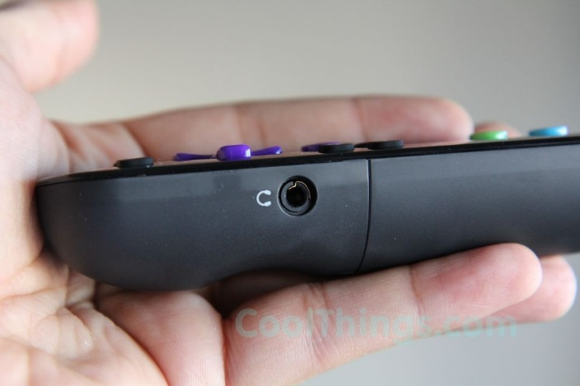want to do. As mentioned earlier, the designers have especially designed the button layout with a reduced number of unnecessary buttons and a proper placement of every button from where it can be easily operated. This interactive design makes the device pretty convenient to use and the functionality of each button could be easily anticipated.

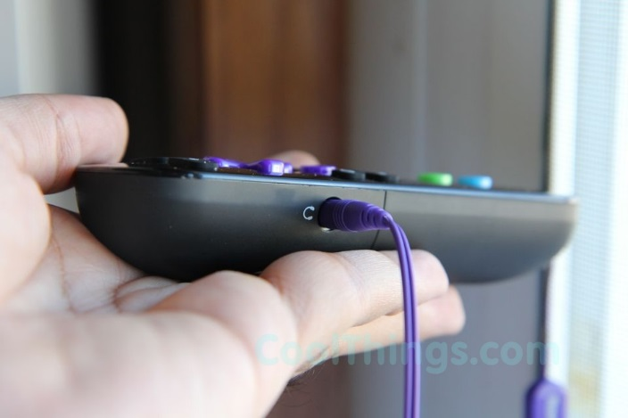An added functionality is the built in headphone jack that you can use when you need to keep the volume down. Just plug in the included in-ear headphones to enter your own private listening world. It’s perfect for cranking up that late-night action movie without waking the spouse. Or kids. Or dog.

1. **Is it easy to remember how to use Ruko 3 Remote control?**

Yes. As mentioned earlier, a user can get started straight away and become competent at carrying out tasks without much ado and it doesn’t take a long time learning how to use the remote control. This is due to the reduced number of unnecessary buttons and a proper placement of every button from where it can be easily operated and remembered. Hence, the buttons of the remote control are not only easy to comprehend at first sight but also very easy to remembered. Over time, the user will not be needed to look at the remote and make it function while looking at the TV or doing whatever they are doing and still hit the correct button.

* **User experience goals**

Now, we shall consider what the interaction with the remote control feels like to the users. This is based on our personal experience with the device and through reviewing user opinions online.

* It is very satisfying to use Ruko 3 to browse through channels and adjust volumes. You do not have to memorize the channel list but rather scroll up and down on the menu using the navigational buttons. There were a total of 16 buttons on the remote and the functionality of each button could be easily anticipated.
* It is aesthetically pleasing to the eye due to its minimalistic color combination and placement of the buttons.
* The added features make it very enjoyable. The Roku3 device offers quite a few games to be played on the TV using the Ruko3 remote as the controller. The remote provides incorporates motion-sensing technology, allowing more precise and detailed control of gameplay. Moreover, when you need to keep the volume down Ruko 3 feature an enhanced remote with built-in headphone jack. Just plug in the included in-ear headphones to enter your own private listening world.

**.**

* **Design principles**

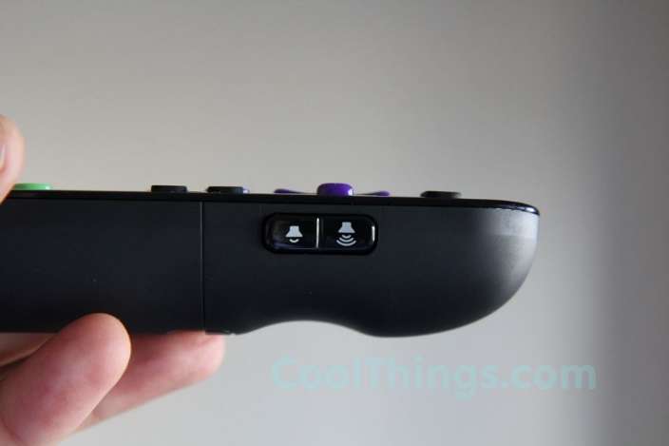**Visibility: Have the designers of Ruko 3 Remote Control considered the visibility principle in designed the control?**

Yes, It has been made very effective and efficient by reducing the number of unnecessary buttons, using appropriate color combinations and properly placing every button from where it can be easily operated and remembered. As you can see in the pictures, the control buttons for different actions are clearly visible (e.g. OK, Settings, Volume adjust, Up and Down) due to both their color and placement, indicating what can be done. The relationship between the way the control buttons have been colored and positioned in the design layout and what they do makes it easy for the user to find the appropriate control for the task at hand.

**Mapping & Consistency: Have the designers properly considered the mapping between control buttons and effects?**

Consider the up and down, right and left navigational arrows used to represent the up and down, and left and right movement of the cursor, respectively. Also consider how the OK button is directly mapped below the navigational buttons. As shown in the picture, the designers have carefully placed every combination of buttons to make sure the user do not find it difficult to perform a task or to get acquainted with the layout.

In other words, the interface is consistent. All the buttons that perform related tasks are grouped together for ease and there are only one set of buttons to perform a specific task. No two buttons or a set perform exactly the same task to create confusion to the user and a visual cluster of objects.

**Affordance**: **Does the design layout give a clue to the user what every button does?**

Yes, every button and its easily-recognizable icon allows the user to easily anticipate it usage. Hence, it is easy to know how to interact with every button. The only two exceptions to this case were the two brightly colored buttons, labelled A and B.



* 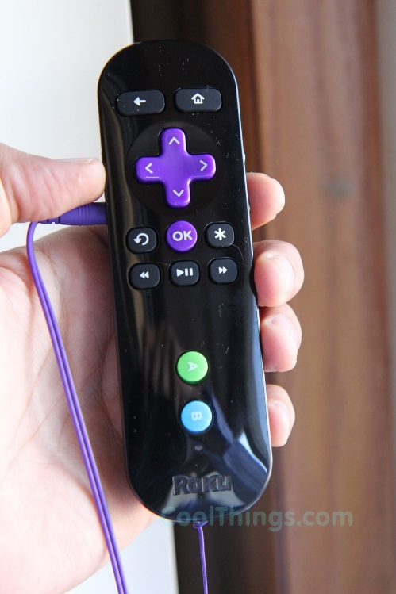Addition of another port for ear plug so that more than one person may be able to use it.
* Buzzer functionality which may help find the remote once it is misplaced in the home.
* Including a direct access mute button in the remote.
* Making the remote peanut shaped to improve the grip. This is quite important considering the fact that the remote is to be used for gameplay too.